TECHNICAL REPORT ON STUDENT INDUSTRIAL WORK EXPERIENCE SCHEME (SIWES)

HELD AT
MINISTRY OF WORKS,
SARDAUNA, TARABA STATE

FROM: 6TH OCTOBER, 2024
TO: 29TH JANUARY, 2025

TITLE PAGE

BY
ISAAC CALEB TANYANG
(SE/ARC/ND/23/022)

SUBMITTED TO THE DEPARTMENT OF ARCHITECTURAL TECHNOLOGY, FEDERAL POLYTECHNIC MUBI, IN PARTIAL FULFILLMENT OF THE REQUIREMENT FOR THE AWARD OF NATIONAL DIPLOMA (ND) IN ARCHITECTURAL TECHNOLOGY

APRIL, 2025

DECLARATION
This is to declare that I, ISAAC CALEB TANYANG with registration number SE/ARC/ND/23/022 undertook my four months SIWES at MINISTRY OF WORKS SARDAUNA, TARABA STATE and have acquired all the experience compiled in this report in the course of my SIWES.

……………………………….. ……………………………
ISAAC CALEB TANYANG Sign/Date

CERTIFICATION
This is to certify that this report compiled by ISAAC CALEB TANYANG (SE/ARC/ND/23/022) meets the requirements governing the award of National Diploma (ND) of the Federal Polytechnic Mubi, and is approved by:

………………………………. ……………………
Name of Supervisor Date
Departmental Supervisor

………………………………. ……………………
Arc. Daniel Nathan Barka Date
Departmental SIWES Coordinator

…………………………………. ……………………
Arc. Mohammed Usman Date
Head of Department

DEDICATION
I dedicate this technical report to my parents, my sisters and colleagues and to all those that supported me throughout my industrial training.

ACKNOWLEDGEMENTS
My sincere appreciation goes to Almighty God and salutation to my Lord Jesus Christ.
My appreciation goes to my beloved parent for the motivation, prayers and financial support towards my SIWES exercise.
My special thanks go to my beloved brothers and sisters for all their care and support throughout my industrial training.
I wish to thank the staff of Architectural Technology department in Federal Polytechnic, Mubi.
I want to also thank my colleagues and others; I really appreciate your efforts.

TABLE OF CONTENTS
TITLE PAGE i
DECLARATION ii
CERTIFICATION iii
DEDICATION iv
ACKNOWLEDGEMENTS v
TABLE OF CONTENTS vi
ABSTRACT ii
CHAPTER ONE 1
1.0 INTRODUCTION 1
1.1 Aim and objective of SIWES 1
1.2 Brief history of SIWES and ITF in Nigeria 2
1.3 Significance of SIWES to students 2
CHAPTER TWO 3
2.1 BRIEF HISTORY OF THE ORGANIZATION 3
2.2 COMPANY ORGANOGRAM 3
CHAPTER THREE 4
3.0 DESCRIPTION OF WORK EXPERIENCE 4
3.1 SITE CLEARANCE 4
3.2 SETTING OUT 4
3.3 BLOCK WORK 7
3.4 UPPER FLOOR CONSTRUCTION 10
3.5 LINTEL CONSTRUCTION 12
3.6 ROOF PITCH CONSTRUCTION 14
CHAPTER FOUR 15
4.0 SUMMARY, RECOMMENDATION AND CONCLUSION 15
4.1 PROBLEMS OBSERVED DURING MY PROGRAM 15
4.2 SUMMARY 15
4.3 CONCLUSION 16
4.4 RECOMMENDATIONS 16
REFERENCES 17

ABSTRACT
The report summarises the result of work done during my SIWES experience, the technical report consists of four chapters; introduction, history and criteria’s of SIWES; aims and objectives, historical background, organizational structure of the organization in chapter two, while chapter three consist of the work actually carried out during the SIWES programme and lastly chapter four consist of the summary, conclusions and recommendation.

CHAPTER ONE

1.0 INTRODUCTION
The acronym (SIWES) meaning “Student Industrial Work Experience Scheme” is a skill training designed to expose and prepare student in institution of higher for industrial working situation they may likely meet after graduation. The scheme is meant to train student on the method of work and the experience needed in handling the equipment and machines may not to be available in their institution. The scheme is financed by the Federal Government and operators through Industrial Training Fund (ITF), Ogwo, (2001) and operates with National University Commission (NUC), National Board of Technical Education (NBTE), and National Commission for College of Education (NCCE) and industries. However, SIWES also expose the student to many practical works which the institution did not treat in details without plastering what the institution taught theoretically into practical. A point from academic obtained. SIWES assist the student to understand the nature of his/her work in future.

1.1 Aim and objective of SIWES
ITF initiates SIWES with the sole aim of: Exposing student with the practical experience related to the theoretical knowledge acquired in school. Bridging the gap between theoretical learning and practical work situation.
- To make industries/organization to have confidence in the abilities and capacities of the graduates. SIWES helps the industries to evaluate the prospective employees and give feedback to the institution.
- It helps the student to gain work and also have experience and confidence as a result if successful completion of a given job assigned to them.
- To enlist and strengthen the employers’ involvement in the institution activities and in the entire educational process of preparing the student for meaningful and productive employment into industries.
- It provides an avenue for student in the Nigerian University and Polytechnics to acquire industrial skill and experience in their course of study.
- Development for greater understanding in other people and proffers skills in human relations.

1.2 Brief history of SIWES and ITF in Nigeria
It was said by Dr. Azikiwe Nnamdi, the one president of Nigeria that the practice of work but they all have the same goal that they all want to achieve in countries like china. They established within the premises of institution to provide real life situation, lack of practical skill of locally trained engineers and technologies. the chine way and condition of SIWES is that all institution must give student real life working experience in industrial works. Lecturers are involved in the industrial activities rendering constant services. So, all these countries have their own way of conducting the scheme but all lye on the same goal. And in Nigeria, the history of SIWES can be traced by the history of IITF which is the backbone of SIWES. ITF was established in 1974 under degree of 47 of 1971. It was a body established by the Federal Government of Nigeria and was given responsibility of training indigenous Nigerians. The establishment of the body became necessary due to high demand of Nigeria to take up the vacant positions created in various sector of the economy after the colonial masters have departed. Therefore, the Federal Government discovered that it is easier to train students that are skilled in school to be trained and meet up with gaps in the Nigerian economy and a scheme was established to care for such training and it was named Student Industrial Work Experience Scheme (SIWES).

1.3 Significance of SIWES to students
Principles taught in the classroom are vein forced given concrete applications on the industrial assignment and students is able to see the relevance of their students which increase their motivation. It helps in given students the knowledge on the types of work to do after his/her graduation. SIWES given students opportunity for a change of environment as they move their institution to the place of attachment which changes the routine types of environment to a word of work. It helps in connecting the institution and the industrial their relationship the introduction of SIWES.

CHAPTER TWO

2.1 BRIEF HISTORY OF THE ORGANIZATION
The Sardauna LGA was created in the year 1976 in the then Gongola State. It was with aim of bringing governance to the people of the Mambilla Plateau. The council was created in order to provide an opportunity for the Local Government to determine their own political, economic and social influence by participating in the making and execution of decision that affects the people of the area i.e., managing their own affairs. The secretariat is situated at the headquarters of the Mambilla plateau, Gembu.

2.2 COMPANY ORGANOGRAM
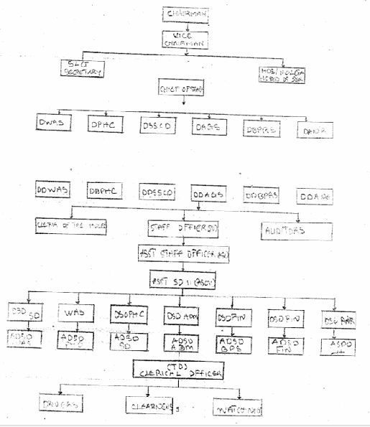
Figure 2.1: Organogram

CHAPTER THREE

3.0 DESCRIPTION OF WORK EXPERIENCE

3.1 SITE CLEARANCE
For the site clearance process, our team took several key steps to ensure the site was ready for construction. First, we gathered all necessary equipment, including shovels, chainsaws, and safety gear, and reviewed the site plan to ensure we understood the requirements. We made sure to obtain the necessary permits and took the time to discuss safety precautions. Next, we cleared the vegetation, carefully handling any environmentally sensitive plants. Construction debris and obstacles like rocks and concrete slabs were removed using heavy machinery, ensuring the site was free of obstructions. Excavation and grading were carried out to level the site and guarantee proper drainage for a solid foundation. Throughout the process, we managed waste responsibly, disposing of both hazardous and non-hazardous materials according to regulations. Finally, a thorough inspection was performed to ensure the site was clean, safe, and fully prepared for the next phase of development.

3.2 SETTING OUT
The Square Method was used to accurately set out rectangular or square buildings by ensuring all corners formed perfect right angles. It was based on the 3:4:5 rule from Pythagoras’ Theorem. The process involved measuring and pegging out straight lines, adjusting angles to form right corners, and confirming accuracy by checking diagonals. This method helped prevent construction errors and ensured the building's structural integrity. As noted by an engineer, accurate calculations during setting out were crucial for the building’s durability
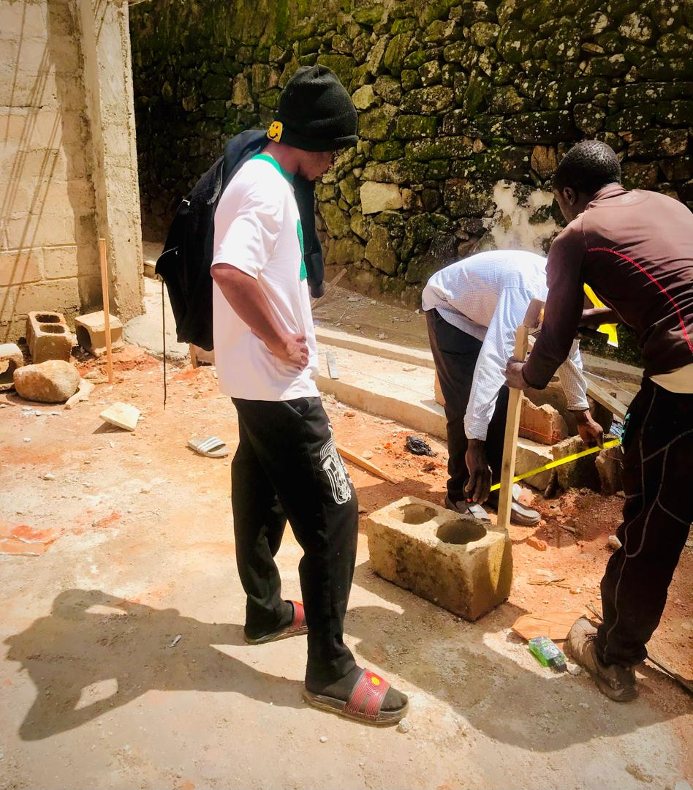
Plate 3.1: Setting out

3.2 EXCAVATION OF FOUNDATION
In this process, the soft surface was dug to lay into trenches. The foundation was dug to the depth of 1.2m and 0.7 meter for width using manual tools such as digger, spade, shovel, hoe and wheel barrow for the moving of excess soil.
Furthermore, the excavation process was started immediately at the setting of the floor plan to the ground. I also observed that during excavation that the site organizer was constantly in site supervising and making sure the depth level and width of the foundation is dully followed by the labourers and mason.
Excavation was done using two methods mechanical and manual. In small construction we normally use manual method while in large construction we use mechanical e.g. like road construction. Excavation work were carried out manually where unskilled labourer where involved with digger, shovels, head pan and wheel barrow. The following factors were considered when carrying out any excavation work.
- Nature of the soil
- The width and depth of foundation
- Climatic condition at the time of excavation
- The water table of the soil
- The period excavation work is expected to be left open.
- The effect of excavation on existing adjacent structure.
As the engineer and the mason goes to set basket, I was keeping an eye on how the beams were set. When digging the basket some places were 1.2 while some other places were 1.4 by 1.4 because of the type of soil on the site. When putting the basket in a poor soil, cement and sharp sand is mixed out before putting the basket to avoid rusting.

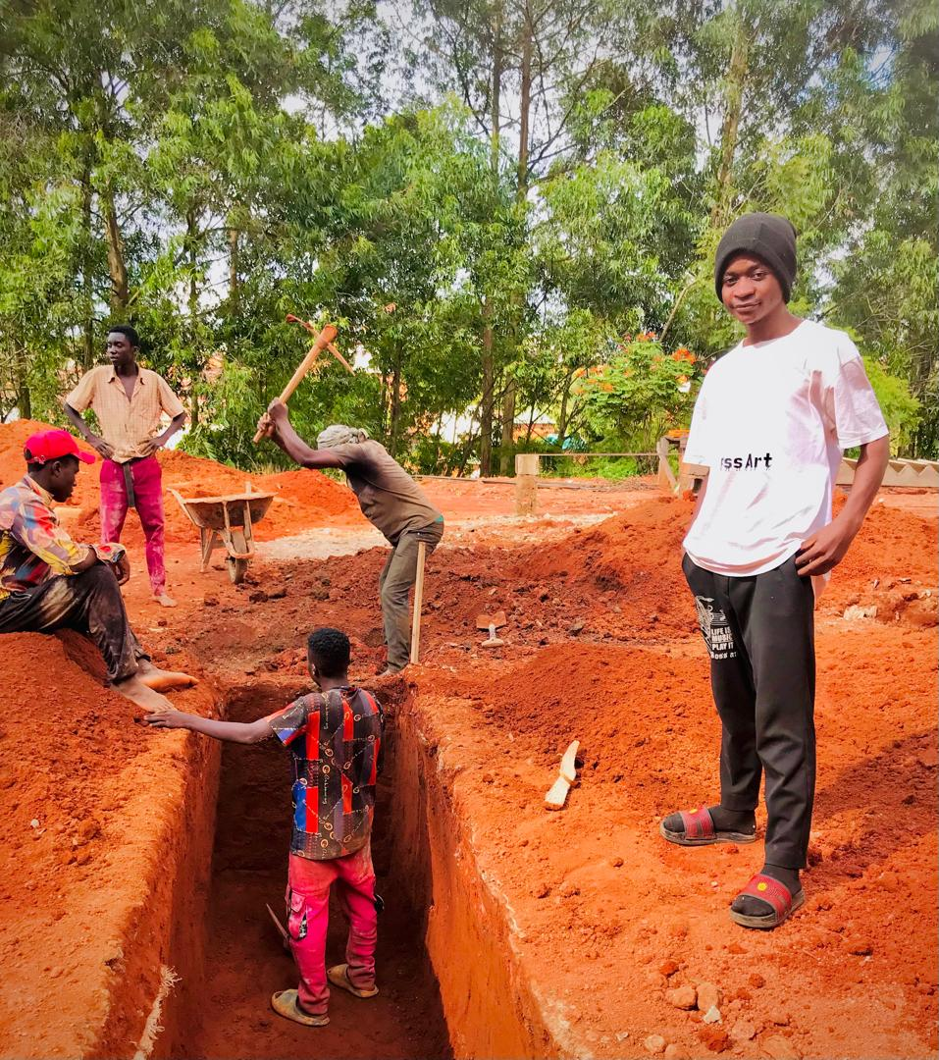
Plate 3.2: Foundation and Excavation

3.3 BLOCK WORK
Blocks were molded in a number of sizes, various compositions, strengths, and shapes such as 9 inches and 6 inches. The 9-inch blocks were used for external walls, while the 6-inch ones were for internal walls. After the foundation work was finished, the blockwork was built to cover the spaces as well. All the blockwork did not carry any load; they were erected to cover spaces and also act as partition walls.
Procedure
- Before starting the block laying process, the site was prepared by clearing debris and ensuring a level foundation.
- The layout of the walls or structure was marked using chalk lines or strings to guide the placement of the blocks.
- Blocks or bricks were selected based on the desired strength, size, and aesthetic requirements of the project.
- Mortar was mixed according to the specifications, typically using a combination of cement, sand, and water.
- A layer of mortar was spread evenly along the foundation where the first course of blocks would be placed.
- A level was used to check the horizontal and vertical alignment of the blocks.
- Once the first course was laid, additional courses of blocks were added on top, following the same process.
- Each block was buttered with mortar on its ends before being placed to ensure a strong bond between the blocks.
- Blocks may have needed to be cut to fit around corners, openings for doors or windows, or to maintain the desired pattern.
- Excess mortar was scraped off the joints using a trowel, and any gaps or voids were filled to create a smooth, uniform surface.
- Once the block laying was complete, the work area was cleaned up, and any excess materials or debris were removed from the site.
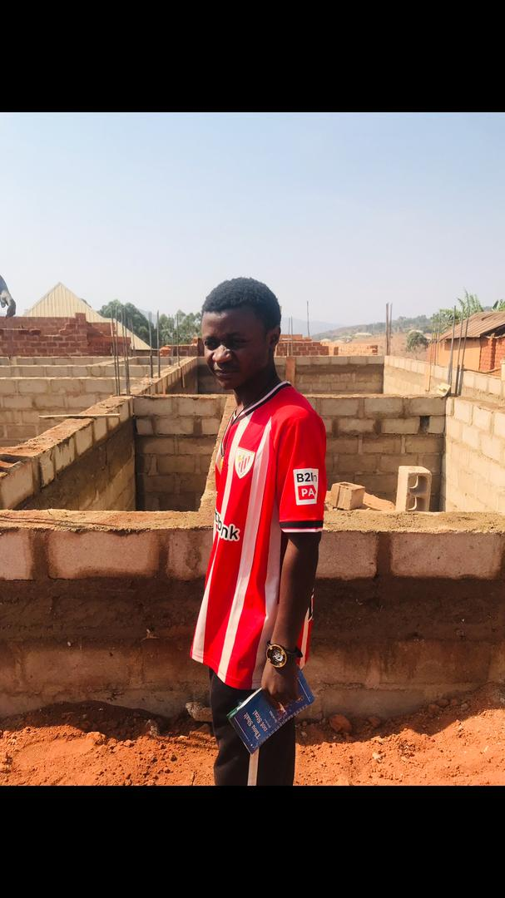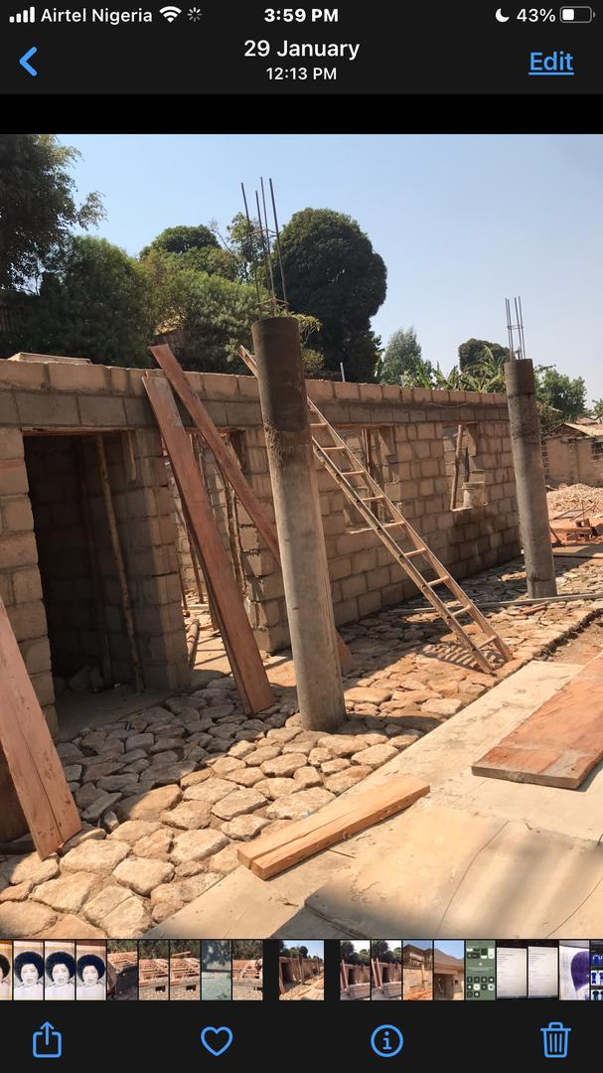
Plate 3.3: Block work

3.4 UPPER FLOOR CONSTRUCTION
After completing the ground floor blockwork and slab, we moved on to the construction of the upper floor, which marked a significant stage in the building’s structural development. This phase involved several activities, including formwork installation, reinforcement fixing, electrical conduit placement, concrete casting, and curing.
We began by erecting formwork and scaffolding to support the upper slab and beams. The carpenters installed the formwork using strong planks and props, ensuring it was well-aligned and firmly braced to carry the load of the wet concrete. Once the formwork was in place, the steel fixers moved in to tie and position the reinforcement bars according to the structural drawing. During this stage, electrical conduit pipes were laid within the slab to allow for future wiring. These were placed in designated positions and tied securely to the reinforcement to prevent movement during casting. After a thorough inspection by the site engineer, we proceeded to pour concrete using a mixture of cement, sand, granite, and water in the appropriate ratio.
The concrete was poured in sections and vibrated properly using a mechanical vibrator to eliminate air pockets and ensure solid compaction. We worked quickly and efficiently to ensure that the concrete was poured continuously to avoid cold joints. Once casting was completed, the surface was leveled and smoothened using a trowel. After the concrete set, we began the curing process by keeping the surface moist for a minimum of 7 days to ensure proper strength development. The formwork was left in place until the concrete achieved sufficient strength to support its own weight and any additional load.

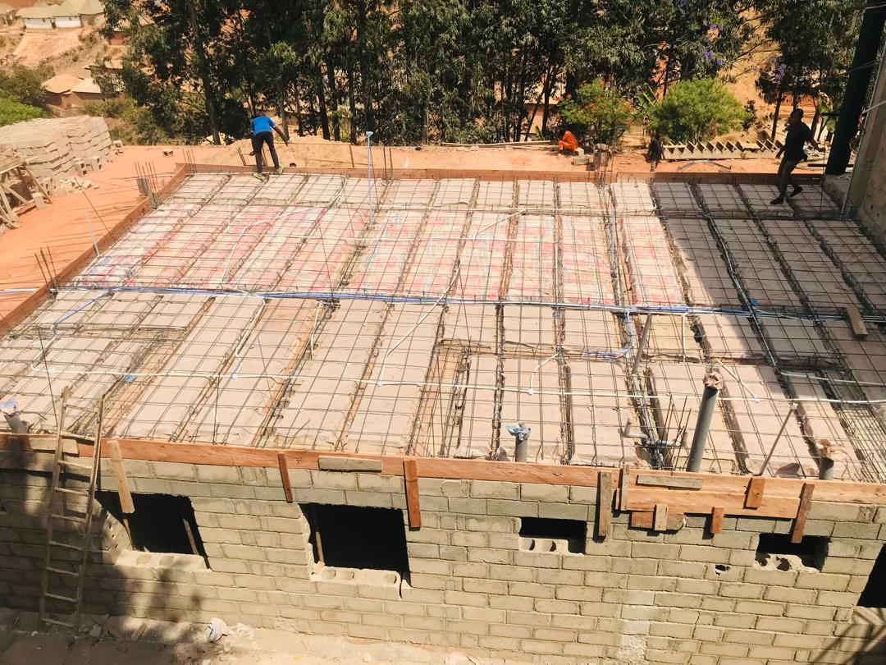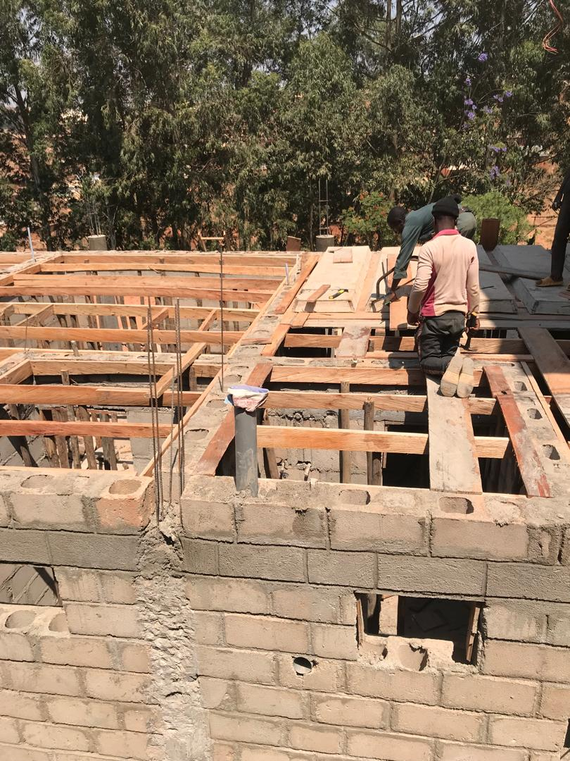
Plate 3.4: Upper floor Construction

3.5 LINTEL CONSTRUCTION
After completing the blockwork up to the required height for doors and windows, we proceeded with the construction of lintels—a critical phase in providing structural support above all openings. The process began with the marking and measurement of all door and window openings to determine the exact length of each lintel. Once the dimensions were confirmed, the carpenters constructed the formwork (shuttering) for the lintels using strong timber, ensuring it was firmly braced and properly aligned.
Next, we tied the reinforcement bars according to the structural drawings. These bars were essential for strengthening the lintel and distributing the load above the openings. Spacers were used to maintain cover between the reinforcement and the formwork, which helps protect the steel from corrosion. Once the reinforcement was fixed and inspected by the engineer, we proceeded to pour concrete into the lintel formwork. The concrete mix was properly proportioned and vibrated to remove air pockets and ensure proper bonding and compaction. The top of the lintel was leveled and finished neatly using a trowel. After pouring, the lintels were left to cure and gain strength, and we kept the surface moist regularly to aid the curing process. The formwork was not removed until the concrete had fully set and reached the required strength, usually after 7 to 14 days. This stage was particularly important as the lintels help in transferring the loads from above openings to the supporting walls on both sides. Being part of this process helped me understand the importance of accuracy, proper formwork, and reinforcement placement in lintel construction.
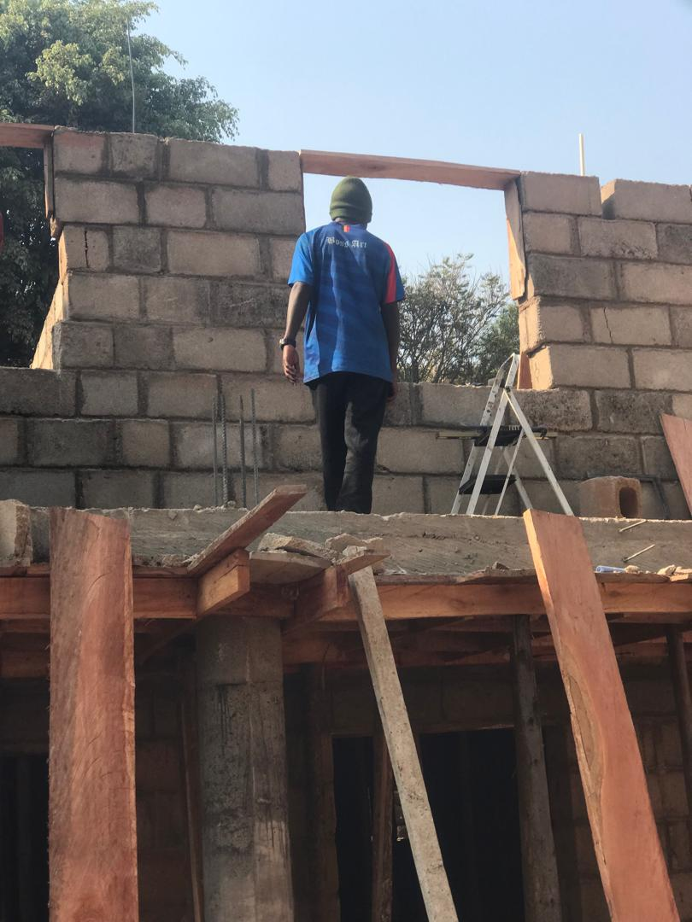
Plate 3.5: Lintel Construction

3.6 PITCH ROOF CONSTRUCTION
During the pitch roof construction phase of the building project, I was actively involved in the planning, preparation, and assembly of the roof structure. The roof pitch, an essential element for water drainage and structural integrity, plays a crucial role in the overall design and performance of the building. After the installation of the main structural framework, the first step was to calculate the correct pitch angle based on the architectural design and the local climate conditions. The pitch is typically determined by the desired water runoff, which is influenced by factors like rainfall and snow load. The higher the pitch, the faster the water will drain off the roof.
With the pitch roof angle established, we began by installing the rafters. The rafters, made from high-strength timber, were carefully measured and cut to the specified length and angle. These were then positioned along the roofline and securely fixed at both ends to the wall plates, forming the skeleton of the roof structure. Each rafter was spaced uniformly to ensure even load distribution and structural stability. As the rafters were set, I observed the installation of the collar ties, which are horizontal beams placed between pairs of rafters to prevent outward movement and provide additional support to the roof structure. We also ensured that the ridge beam, located at the top of the roof, was securely anchored and aligned with the rafters to create a strong and stable peak.
In addition to the structural elements, the installation of roof trusses was performed for certain sections of the building. These prefabricated triangular structures helped to distribute the roof load more evenly across the walls and supported the weight of the roofing material. The trusses were lifted into place using a crane, ensuring that they were properly aligned and braced.
Once the rafters and trusses were securely in place, we began applying the roofing material. Depending on the design, this could include metal sheets, tiles, or shingles. I assisted in carefully securing the roofing material to ensure there were no gaps or vulnerabilities where water could infiltrate. Special attention was given to areas such as roof valleys and eaves, where additional sealing and waterproofing were necessary. Finally, the roof pitch was thoroughly inspected to confirm that the angle was consistent across the entire structure and that all materials were properly installed. Once completed, the roof pitch not only ensured effective water drainage but also enhanced the building’s aesthetic appeal.

CHAPTER FOUR

4.0 SUMMARY, CONCLUSION AND RECOMMENDATIONS

4.1 PROBLEMS OBSERVED DURING MY PROGRAM
- The time frame set for the program is too short as some of the aspects of the program where not completed.
- Lack of Financial support from the company to aid transportation to and from training.
- Attentions are not given to the IT students by the workers it is learn if you want to learn or ask if you want to know.

4.2 SUMMARY
One would state that the discipline is the training of the mind and body towards effective performance. The Students Industrial Work Experience Scheme (SIWES) is more or less achieving this fit. As it further builds on the theoretical classrooms leaving a practical approach of the industry and commerce to supply of finished goods and services. This program has enabled the participating students to be practically involved in the day-by-day activities of the industries and commerce.
Emphasis in the observation of industrial safety rules and regulations, time critical operation and proper man-hand management, quality cortices, etc. are daily activity objective. All those aimed at the production of marketable goods and services in the world of work.
However, to consolidate on the gains of this Industrial Training Fund (ITF) higher institution coordinator on SIWES program should be allowed making some suggestion and recommendation.

4.3 CONCLUSION
The SIWES programme has been fulfilling through meeting students form other institution and departments. I had a practical sense of executing building construction. I have a good sense of the importance of any industrial training.

4.4 RECOMMENDATIONS
Having being exposed to a bit of what entail working in an industry related to my course of study under SIWES programme I wish to make this recommendation
- Higher instruction of learning especially either institution and universities should establish link with professional bodies so as to provide space for student on industrial attachment, with the option of gaining employment in future, by doing so, it will go a long way in alleviating suffering and difficulties encountered by student in securing place for individual attachment.
- Orientation and mentorship programs should be introduced at the beginning of the SIWES placement to guide students on expectations, safety protocols, and learning objectives. This will help maximize the learning experience and ensure students are better integrated into the work environment.

REFERENCES
Brown, T. L., & Green, M. D. (2019). The impact of foundation design on structural integrity. Journal of Structural Engineering, 45(3), 225-240.
Edward, B. (2003). The Effect of SIWES on a student, Federal Ministry of Works, Lagos. Nigeria.
Sarduana Local Government Area Secretariat (2024). Ministry of Works, Gembu, Taraba State.
Smith, J. A. (2020). Building structures: An introduction to civil engineering (2nd ed.). McGraw-Hill.
White, P. R., & Black, C. L. (2018). Innovations in sustainable construction materials. In Proceedings of the 10th International Conference on Civil Engineering (pp. 134-141). Engineering Society Press.

